<Mutant Werecats from Outer Space> (ReplaceMe: need official logo art)

Design Document

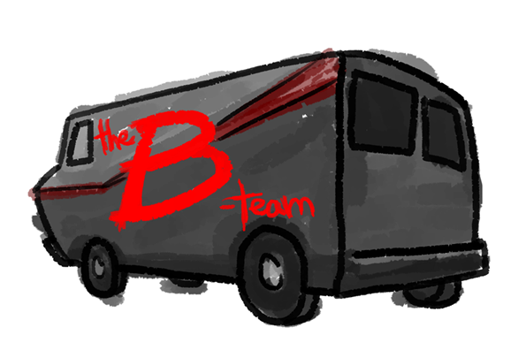

Programming and Story

Thomas Dye [thomas@tfenet.com](mailto:thomas@tfenet.com)

Cary Kawamoto [cary.kawamoto@gmail.com](mailto:cary.kawamoto@gmail.com)

Andrew VanKooten [andrewvankooten@gmail.com](mailto:andrewvankooten@gmail.com)

Holden Woelfl [hjwoelfl@gmail.com](mailto:hjwoelfl@gmail.com)

Art

Lori Collins [loriofpandora@gmail.com](mailto:loriofpandora@gmail.com)

Concept and Story

Amani Dye [amaniahmeddye@live.com](mailto:amaniahmeddye@live.com)

Music

Unlisted.

Contents

Version History 3

Version 0.1 - April 27, 2016 3

Game Overview 3

Game Details 3

Concept 3

Game Tags 3

Genre 3

Player 4

Game Length 4

Audience, Platform, and Market 4

Target Audience 4

Platform 4

Similar Games 4

Game Mechanics 5

Conversion 5

Movement 5

Influence 5

Small Horde 5

Large Horde 6

Environmental Hazards 6

Active Hazards 6

Difficulties 6

Characters and Art 7

Player 7

Basic (undetailed) Body Poses 7

Detailed Body Variations 8

Humans 8

Basic (undetailed) Body Poses 8

Detailed Body Variations 9

Hazards 9

Background Textures 9

User Interface 10

Music and Sound Effects 10

# Version History

## Version 0.1 - April 27, 2016

Initial draft of the document.

Added:

* Game Overview
* Dame Details
* Audience, Platform, and Marketing
* Game Mechanics
* Characters and Art
* User Interface
* Music and Sound Effects

# Game Overview

Mutant Werecats from Outer Space is a casual 2D side-scrolling “horde management” action game where you control a growing swarm of housecats, helping aliens take over the Earth by converting humans into felines.

# Game Details

## Concept

A shadowy alien race enlists the help of the dominant species on earth (as known by them through research conducted on YouTube): the housecat. They decide to turn ordinary housecats into “werecats” that look like normal cats, but have the ability to turn unsuspecting humans into cats by a process known as “bapping.” The converted humans join the werecats as members of their horde to grow the horde in size and over power larger groups of humans until there are no more humans are left.

One morning you wake up and realize you’re a cat filled with glorious purpose and bent on world domination. It is your goal to build a horde of cats so you can take over larger and larger areas of the world until ultimately everyone is converted to a cat. The player wins if influence is maintained over the horde until all humans are converted, but long periods of time without adding humans to your horde or obstacles in the world will cause your horde size to decrease, preventing you from winning.

## Game Tags

Casual, Cute, 2D, Horde/Swarm/Mob Management, Simple, Non-Violent

## Genre

“Casual Horde Management”

This is a casual game. It shouldn’t require a lot of strategy or micromanagement. Only simple actions. The player is one step ahead of the current situation, and has only basic reactions.

## Player

The player starts the game as a single cat that has been turned into a werecat by the aliens. This cat is differentiable from the other cats in the game by a unique texture, but there is some variation with this texture to allow for some player choice.

## Game Length

There are multiple levels that are created for this game, with each level taking a different amount of time to complete based on its difficulty, but as this game is designed for casual and completionist players, the time to play the game is variable. Levels are intended to be replayed to complete secondary challenges and earn better scores.

# Audience, Platform, and Market

## Target Audience

Mutant Werecats from Outer Space is a casual, action game meant for all ages. This game appeals to players who are looking to pick it up and play for a few minutes, as well as completionist type players who will be able to go back to previously completed levels, and try to meet specific challenge objectives that will give them bonus throughout the game.

## Platform

This game was created with Windows PC and mobile in mind. The UI is designed to be simple and easy to use making both the platforms ideal choices. There is also a possibility that this game can be adapted to be used with a console.

## Similar Games

There are a few games currently on the market that present similar themes as Mutant Werecats from Outer Space.

* **Zombie Horde Game**

This game has the player control a zombie to find humans and stay by them to convert them to zombies that will join your horde. This game is similar to ours with respect to the convert humans and horde mechanic. Mutant Werecats from Outer Space introduces additional mechanics and levels, while featuring lighthearted elements and humor making this game more appropriate to broader audiences.

<http://www.freewebarcade.com/game/zombie-horde-game/>

* **Agar.io**

Agar.io is a multiplayer game where players start as a circle and compete with other players to “eat” smaller circles to grow in size. This follows Mutant Werecats from Outer Space’s theme of growing the size of your horde, but with the additional challenge of finding humans to convert and with no multiplayer component.

<http://agar.io/>

* **The Last Guy**

Released as a digital download for the PS3, this game is somewhat similar to Snake; as survivors are rescued, they are added to the chain of people following the Hero. A longer chain makes it easier to surround and add new survivors, but also means more places to contact enemies on the field.

<https://www.playstation.com/en-us/games/the-last-guy-ps3/>

* **Katamari Damacy**

The player controls The Prince, tasked by his father The King of All Cosmos to roll up and collect mundane objects from Earth to restore the stars in the sky. Each stage has different requirements for completion, including size, quantity, and item types. The level and hazards scale up as the player grows in size -- some areas become accessible, and the nature of certain challenges changes.

<https://en.wikipedia.org/wiki/Katamari_Damacy>

# Game Mechanics

## Conversion

The player converts humans into cats by “bapping” them on their head. Being “bapped” and converted to a cat is permanent. Humans must be in a prone position to be “bapped” on the head by a cat, which is easier when the horde is small and gets harder when the horde grows. The player must stay by the converting human for a set amount of time, depending on the difficulty, in order to ensure that it becomes part of the players horde, otherwise the new cat will run away.

## Movement

The player has influence over the horde, directing travel locations by moving around a map. If a human is encountered, the player must move the horde toward the human. As the horde also becomes aware of the human (through relative proximity), the horde will independently move, and start to convert the human.

## Influence

The alien’s influence over the player, and by extension, the player’s influence of other cats, is temporary. A countdown shows the amount of time you have influence over your cat. If another human is converted to a cat, your influence timer stops and a new timer starts on the newest member of your horde. Each additional cat added to your horde gets a new influence timer with the previous timer stopping. Allowing the timer to expire means the player loses influence over that particular cat, and it walks away (as a normal cat). If the player loses the horde and player’s timer resumes and expires, the player becomes a normal cat and the game is lost.

## Small Horde

The player will not be able to overwhelm humans with a small horde, so techniques must be used to allow werecats to bap humans, who are physically larger than cats. Techniques may include walking up to humans and rubbing their legs, purring, rolling around on the ground--anything to get the human to bend over and pet the cat. Once prone, the werecat may bap the human.

## Large Horde

Humans are less trustworthy of the larger group of cats and may employ countermeasures (see environmental and active hazards section) to avoid conversion and try to break up the horde. The horde must corner humans before the human can be overwhelmed and bapped.

## Environmental Hazards

Humans will randomly place environmental hazards in the way of the horde to try to disperse it, because large groups of cats are suspicious. These appear on easier difficulties when the horde is not incredibly large.

* Boxes
* Cucumbers
* Rocking Chairs
* YouTubers trying to film cats
* People trying to pick up and leaving with cats

## Active Hazards

After the horde has reach a large enough size and the difficulty is high enough, humans will begin to throw these at the horde to make it disperse. The player must deal with these with directly, with overwhelming force, before too many cats are lost.

* Dogs
* Animal Control
* Balls of Yarn

## Difficulties

There are four difficulties in the game. Each level has a set difficulty and after the player beats a level at the set difficulty, they can go back and play it at any difficulty. The difficulty help determine the values and modifiers of some game play elements.

* **Easy**: Few humans are spawned and the horde size needed to beat the level is low. The time needed to convert a human is low, and the overall timer for you and other cats is higher. Humans are also less alert to the threat of the horde.
* **Average**: More humans are spawned, and the required horde size is larger. The conversion timer is higher, and the overall timer is lower. Humans are slightly more alert, and begin placing environmental hazards.
* **Hard**: Even more humans are spawned, and required horde size is even larger. The conversion timer is much higher, and the overall timer is much less. Humans are way more alert and are placing active hazards to stop the horde.
* **Challenge**: The largest amount of humans are placed, and horde size needed is close to 100 percent. The conversion timer is at the highest, and the overall timer is much smaller. The active hazards are even more dangerous.

# Characters and Art

## Player

The player cat should be highly animated. Recolor the player cat sprite sheet to allow variation. Body type variation requires additional animation assets, which are out of scope for this release. The player cat must be distinct from the cats in the horde, and the horde cats must have slight variations between them.

### Basic (undetailed) Body Poses

Sitting

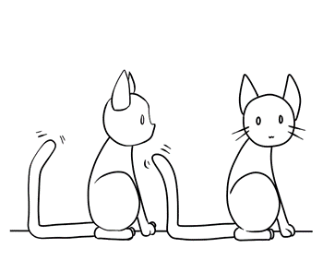

Jumping

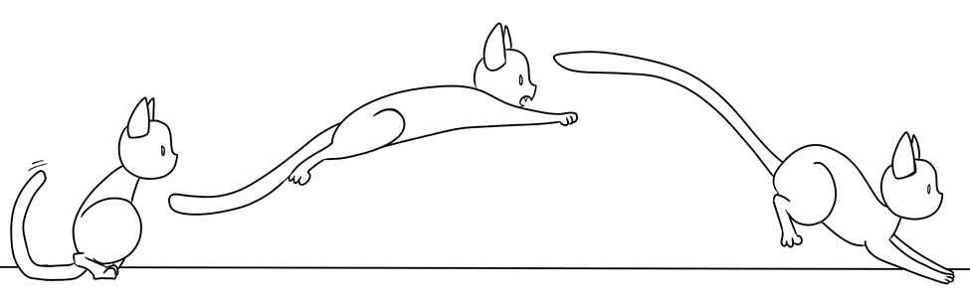

Walking

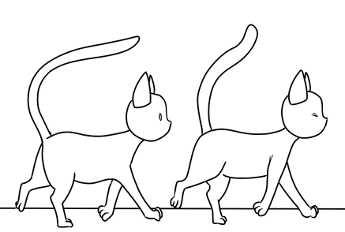

### Detailed Body Variations

Sitting

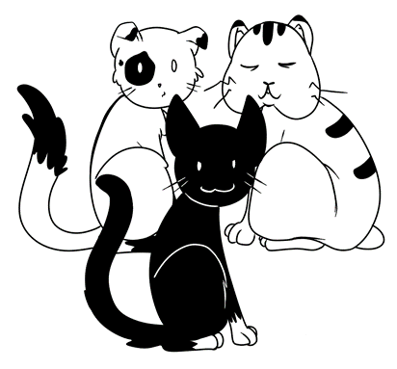

## Humans

### Basic (undetailed) Body Poses

Kneeling (and being bapped)

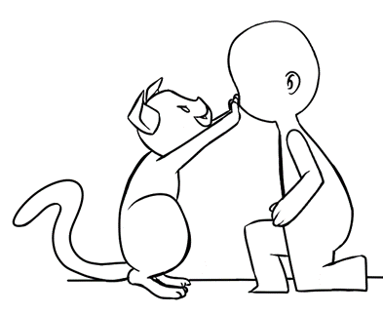

Standing

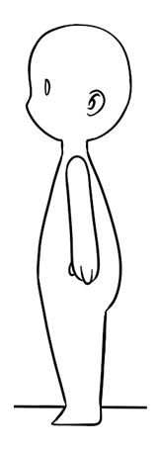

### Detailed Body Variations

Standing

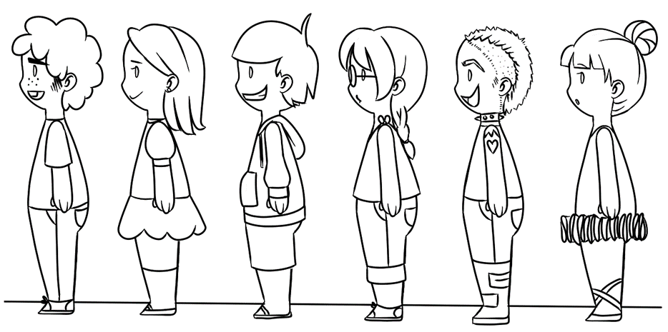

## Hazards

Currently there are no assets for hazards.

## Background Textures

Backgrounds will be made to be modular, so they can be easily be reused to enable larger levels. These backgrounds will include both inside and outside elements. All backgrounds will contain three elements:

* **Sidewalk / Floor**: Space where the player and humans can walk. Also where hazards will spawn. This is going to be the bottom half of the background, which will be similar to those familiar with the 2.5 dimensional environment.
* **Building / Wall**: The top half of the background where the player and humans cannot walk on.
* **Obstacles**: Random elements, such as trees, on the sidewalk / floor part of the background which the players cannot walk over.

# User Interface

The UI in this game is going to reflect the simple and casual nature of the game. Immediate information will be reflected on the screen such as the number of zombies in the horde, and the percentage of humans left in the level. Other information the player needs will be reflected in the objects on the screen, such as the influence on a cat will be represented by the color of the eyes of that cat.

The game is designed with both computer and mobile inputs in mind, so the controls are designed to be simple and intuitive. The player cat will be controlled by using the mouse and “bapping” a human by clicking.

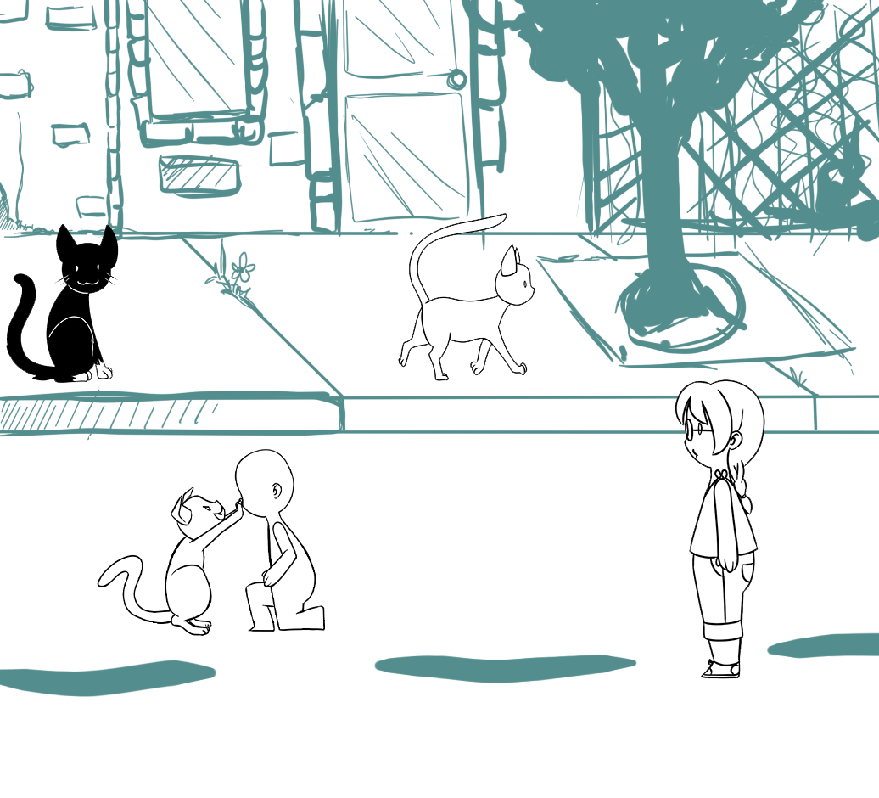

The above image is a composite mockup of potential gameplay. UI elements are not currently reflected in this image.

# Music and Sound Effects

No music and sound effects are currently made. Sound effects are expected to be created by us, and music will be provided by Danny Morris <https://soundcloud.com/dannymorris-1>